ECE3003- Microcontroller and its Applications

Lab Slot: L37+L38

Prof. Chitra P

Submitted By: Rishab Dhar (16BEC0034)

**TASK IV**

Part a) Serial Communication

Program 1

Write an 8051 assembly program to transfer data “A” serially at baud rate 9600 with 8 bit data, one stop bit and observe the transmitted data in the serial window of the simulator.

CODE:

ORG 0000H

XX: MOV DPTR,#MYDATA

MOV TMOD,#20H

MOV TH1,#-3

MOV SCON,#50H

SETB TR1

MOV R1,#14

AGAIN: CLR A

MOVC A,@A+DPTR

MOV SBUF,A

HERE: JNB TI,HERE

CLR TI

INC DPTR

DJNZ R1,AGAIN

SJMP XX

MYDATA: DB 'VIT UNIVERSITY'

END

OUTPUT:

Program 2

Write a 8051 Assembly Language program to get data from the PC and display it on P1. Assume 8051 is connected to PC and observe the incoming characters. As you press a key on the PC's keyboard, the character is sent to the 8051 serially at 4800 baud rate and is displayed on LEDs. The characters displayed on LEDs are in ASCII (binary).

CODE:

ORG 0000H

MOV TMOD,#20H

MOV TH1,#-6

MOV SCON,#50H

SETB TR1

HERE:JNB RI,HERE

MOV A,SBUF

MOV P1,A

CLR RI

SJMP HERE

END

OUTPUT:

Task 4A

Write a program to send the message “India is our Country” to serial port. Assume a SW is connected to pin P1.2. Monitor its status and set the baud rate as

Follows:

SW = 0, 4800 baud rate

SW = 1, 9600 baud rate

Assume XTAL = 11.0592 MHz, 8-bit data, and 1 stop bit. Use Hyper terminal for your Results

CODE:

ORG 0000H

HERE:

MOV TMOD,#20H

MOV TH1,#-6

MOV SCON,#50H

SETB TR1

SETB P1.2

SW1:JNB P1.2,XX

MOV A,PCON

SETB ACC.7

MOV PCON,A

SJMP HERE2

XX:

MOV A,PCON

SETB ACC.7

MOV PCON,A

HERE2: MOV DPTR,#MYDATA

BACK:CLR A

MOVC A,@A+DPTR

JZ SW1

ACALL TRANS

INC DPTR

SJMP BACK

TRANS:

MOV SBUF,A

HERE1: JNB TI,HERE1

CLR TI

RET

MYDATA: DB 'India is Our Country'

END

OUTPUT:

Task 4B

Write a program to send the message “YOUR NAME” and “REGISTER NO” to serial port. Assume a SW is connected to pin P1.2. Monitor its status and set the baud rate as

Follows:

SW = 1, Send “YOUR NAME” at 9600 baud rate

SW = 0, Send “REGISTER NO” at 19200 baud rate

Assume XTAL = 11.0592 MHz, 8-bit data, and 1 stop bit.

Use Hyper terminal for your Results

CODE: (To Modify)

SW BIT P1.2

ORG 0H ; starting position

MAIN:

MOV TMOD, #20H

MOV TH1, #-6 ; 4800 baud rate (default)

MOV SCON, #50H

SETB TR1

SETB SW ; make SW an input

S1: JNB SW, SLOWSP ; check SW status

MOV A, PCON ; read PCON

SETB ACC.7 ; set SMOD high for 9600

MOV PCON, A ; write PCON

SJMP OVER ; send message

SLOWSP:

MOV A, PCON ; read PCON

SETB ACC.7 ; set SMOD low for 4800

MOV PCON, A ; write PCON

OVER: MOV DPTR, #MESS1 ; load address to message

FN: CLR A

MOVC A, @A+DPTR ; read value

JZ S1 ; check for end of line

ACALL SENDCOM ; send value to serial port

INC DPTR ; move to next value

SJMP FN ; repeat

SENDCOM:

MOV SBUF, A ; place value in buffer

HERE: JNB TI, HERE ; wait until transmitted

CLR TI ; clear

RET ; return

MESS1: DB “The Earth is but One Country”,0

END

OUTPUT:

Part b) Interrupts

Program 1

Write an 8051 program to get data from port P0 and send it to port P1 continuously while an interrupt will do the following: Timer 0 will toggle the P2.1 bit every 100 microseconds.

CODE:

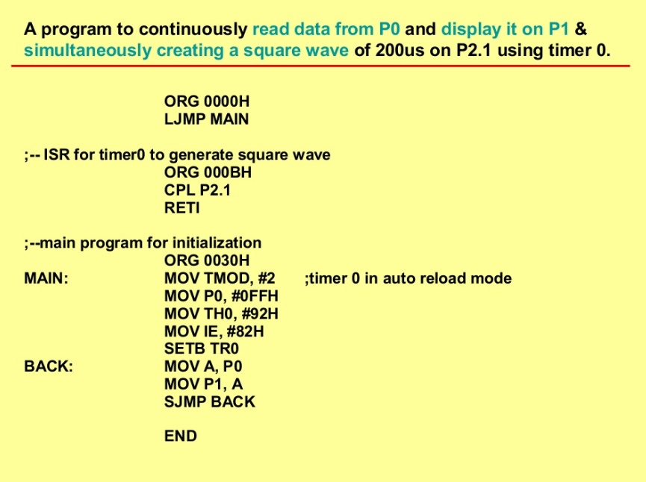

OUTPUT:

Program 2

Write an 8051 program to get data from a single bit of P1.2 and send it to P1.7 continuously while an interrupt will do the following: A serial interrupt service routine will receive data from a PC and display it on P2 ports.

CODE:

OUTPUT:

Task 4C

Write a program using interrupts to do the following:

a) Receive data serially and sent it to P0,

b) Make timer 0 generate a square wave of 100micro second time period on P1.0.

Assume that XTAL-11.0592. Set the baud rate at 4800.

CODE:

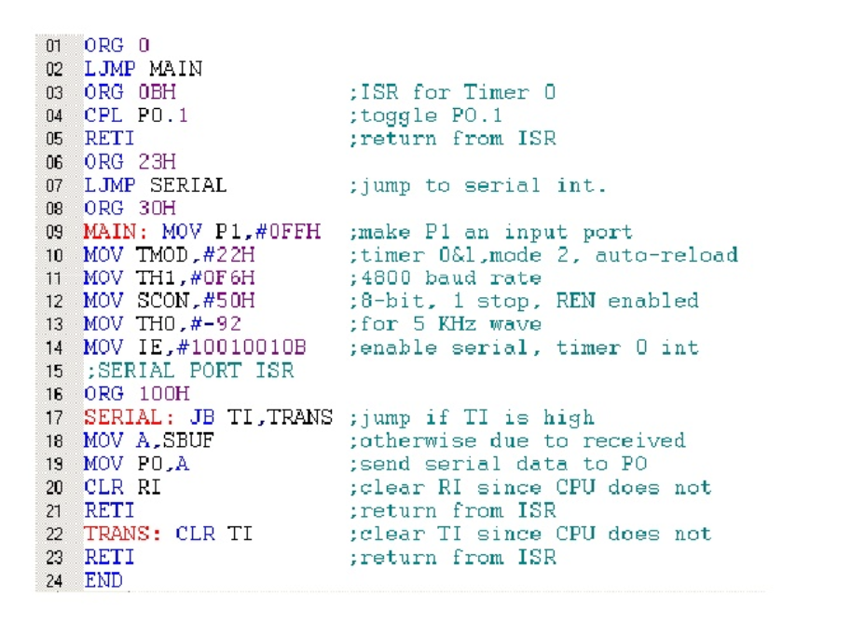

OUTPUT:

Task 4D

Write an 8051 assembly program using timer 0 to generate a 500 Hz and timer 1 to 7kHz square wave frequency on P1.0 and P1.1 respectively using Interrupts. Then examine the frequency using the KEIL IDE inbuilt Logic Analyzer.

CODE:

OUTPUT: